Nama : Wisnu abdi buana

Nim : 210511125

Kelas : R3

PBO2 Praktikum 3

Overload 1

|  |
| --- |
| '''  Nama : Wisnu abdi buana  Kelas : R3  NIM : 210511125  Overload1 ''' class Math: def add(self, a, b=None, c=None):  if b is not None and c is not None:  return a + b + c elif b is not None: return a + b else:  return a  m = Math() print(m.add(7)) print(m.add(9, 3)) print(m.add(8, 3, 7)) |

Hasil Running Program

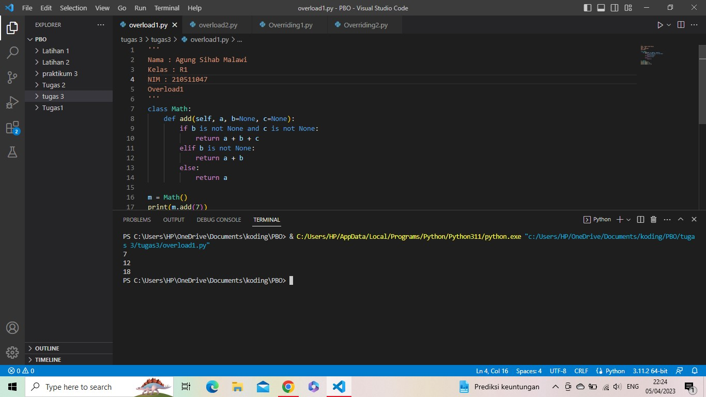

Overload 1

|  |
| --- |
| '''  Nama : Agung Sihab Malawi  Kelas : R1  NIM : 210511047  Overload2 ''' class Math: def add(self, *args):  total = 0 for arg in args: total += arg return total  m = Math() print(m.add(9)) print(m.add(50, 3)) print(m.add(8, 4, 16)) |

Hasil Running Program

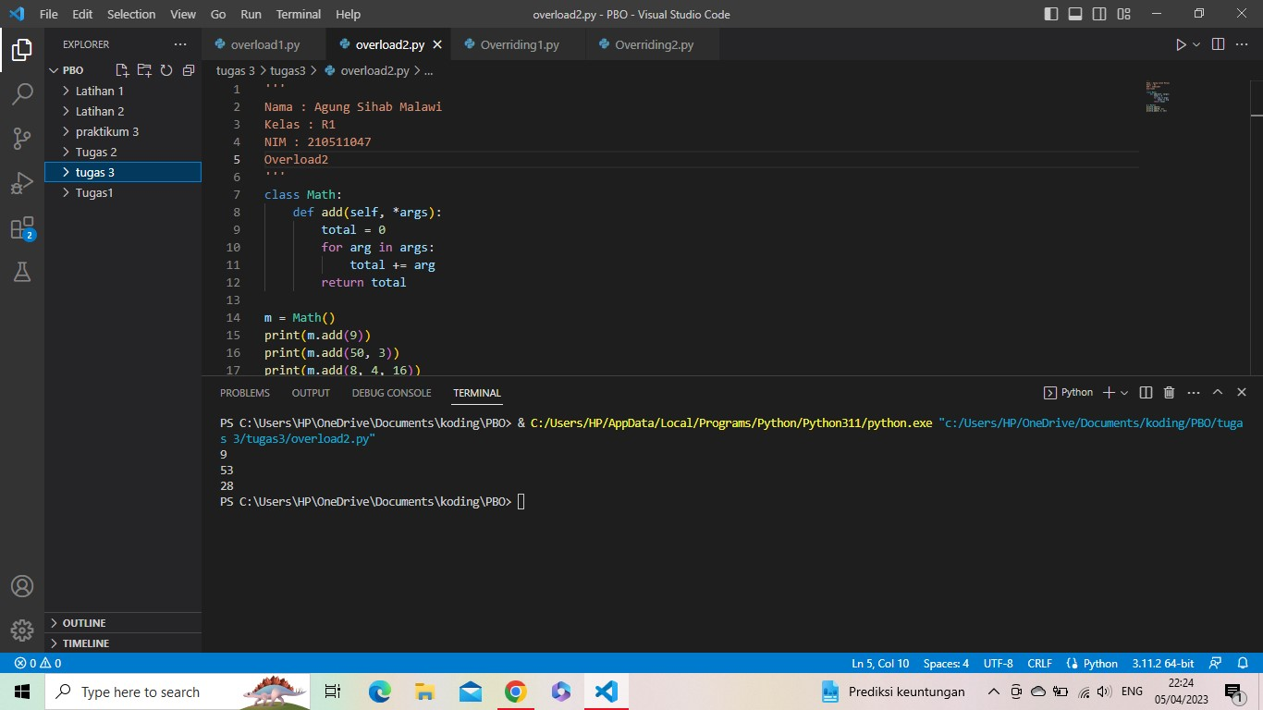

Overriding 1

|  |
| --- |
| '''  Nama : Agung Sihab Malawi  Kelas : R1  NIM : 210511047  Overriding1  ''' class Pekerja: def __init__(self, name):  self.name = name  def gaji(self):  raise NotImplementedError  class Supervisor(Pekerja): def gaji(self):  return ' Rp 3.000.000'  class Manajer(Pekerja):  def gaji(self):  return ' Rp 5.000.000'  class Mekanik(Pekerja): def gaji(self):  return ' Rp 2.500.000'    parapekerja = [Supervisor('Sihab'), Manajer('Agung'), Supervisor('Tegar'), Mekanik('Sultan')]  for pekerja in parapekerja:  print(pekerja.name + ': ','Gaji/bulan' + pekerja.gaji()) |

Hasil Running Program

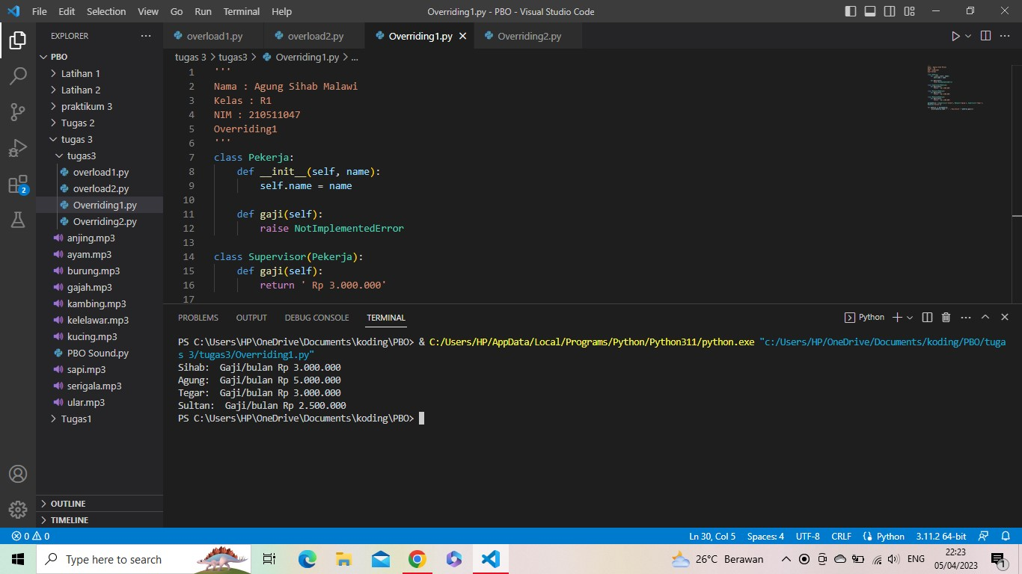

Overriding 2

|  |
| --- |
| '''  Nama : Agung Sihab Malawi  Kelas : R1  NIM : 210511047  Overriding2  ''' class Hero: def __init__(self, name):  self.name = name  def gaji(self):  raise NotImplementedError  class Fighter(Hero): def gaji(self):  return ' Exp Liner'  class Assasin(Hero): def gaji(self):  return ' Junggler'  class Tank(Hero): def gaji(self):  return ' Roamer'  class Marksman(Hero): def gaji(self):  return ' Gold Liner'  class Mage(Hero): def gaji(self):  return ' Mid Liner'  class Support(Hero): def gaji(self):  return ' Roamer/Mid liner'    heroml = [Fighter('Yin'), Tank('Johnson'), Mage('Vale'), Support('Estes')] for hero in heroml:  print(hero.name + ': ','Jalur' + hero.gaji()) |

Hasil Running Program

